Robot Control Problem Set 7
  - Operational Space Control
  - Will Graham

Jacobian Inverse Control
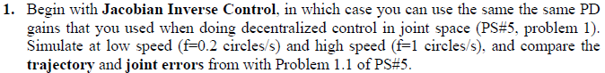

Simulink Model

Jacobian Inverse Control Function
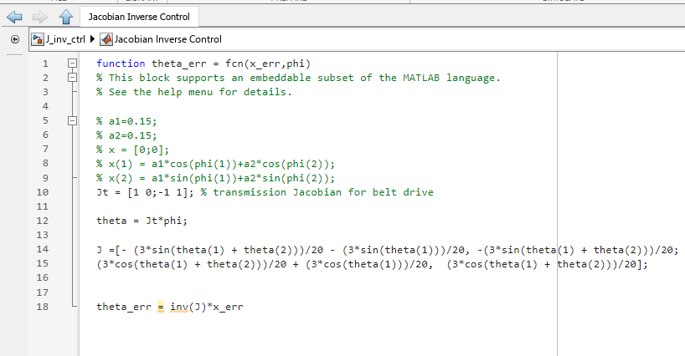
Note: The symbolic calculation of the Jacobian is found within the attached PS7 code. This was used in future Jacobian calculations.

Jacobian Inverse Control Results

PD Control

Comparison Table for f = 1 circles/second
 | JIC Control | PD Control | Difference
X Max, Y Max [m] | 0.007, 0.010 | 0.103, 0.032 | -0.096,-0.022
X RMS, Y RMS [m] | 0.003, 0.006 | 0.037, 0.016 | -0.034,-0.01
Joint 1 Max, Joint 2 Max [deg] | 6.366, 7.902 | 5.889, 1.829 | 0.477,6.073
Joint 1 RMS, Joint 2 RMS [deg] | 2.173, 3.033 | 2.111, 0.938 | 0.062,2.095

Comparison Table for f = 0.2 circles/second
 | JIC Control | PD Control | Difference
X Max, Y Max [m] | 0.003, 0.005 | 0.030, 0.010 | -0.027,-0.005
X RMS, Y RMS [m] | 0.002, 0.003 | 0.016, 0.007 | -0.014,-0.004
Joint 1 Max, Joint 2 Max [deg] | 1.735, 1.688 | 1.730, 0.556 | 0.005,1.132
Joint 1 RMS, Joint 2 RMS [deg] | 0.906, 1.126 | 0.911, 0.379 | -0.005,0.747

Jacobian Transpose Control

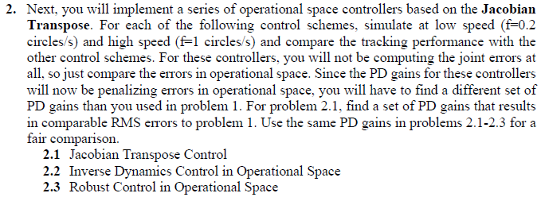

Jacobian Transpose Control

Simulink Model

Plots

Inverse Dynamics Control in Operational Space

Simulink Model

Plots

Robust Control in Operational Space
Couldn’t get around to this. Had a concussion, and didn’t have enough time to learn and implement this.

